Analysis System for GAthered Raw Data
ASGARD is a project that has received funding from the European Union’s Horizon 2020 - Research and Innovation Framework Programme, under grant agreement no 700381.

PROJECT OVERVIEW
Version: | 1.0
Delivery date: | 2016-11-10
Dissemination level: | Public
Author(s): | Juan Arraiza | Vicomtech-IK4

Contents
1. ASGARD in a nutshell 2
2. ASGARD Consortium 3
3. Conceptual view of the implementation strategy 4
4. ASGARD components 5

ASGARD in a nutshell
PROJECT AIMS  Provide LEAs with Technological Autonomy by creating a long lasting community of LEAs and the research and development industry, focused on a set of tools and techniques, that facilitate effective collaboration in order to define, develop, share, and evolve open source big data technology solutions that will help LEAs prevent and fight against crime and terrorism. | VISION  By the end of the project ASGARD will deliver an active and sustainable community of practitioners that has found a valid and sustainable model for all participants and has successfully delivered and evaluated the tools & infrastructure developed during the project, reinforcing all participants’ motivation to participate in the community.
STRATEGY  - Fluid, Frequent, and Fruitful collaboration between all stakeholders, including short development cycles and face-to-face “Hackathons” every 6 months. After the hackathons LEAs will be able to take the tools, deploy and test them in their own premises and with their own data providing feedback to the ASGARD community.  - Build the sustainable community starting with a large representation of the different stakeholders in the strong ASGARD consortium.  - Definition and design of the solution based on (1) forensic, intelligence and foresight processes, (2) end-user needs driven use cases and scenarios, (3) SoA technologies and beyond SoA achievable challenges, and (4) Social, Ethical, Legal, and Privacy aspects. | IMPACT  - ASGARD will enhance LEAs’ efficiency and capabilities in forensic, intelligence, and foresight by delivering a set of easily configurable and deployable tools and applications (not a monolithic platform). The tools to be delivered will be prioritised by LEAs. Each tool will be designed and developed to tackle a specific task, whether it be data or task driven. User-friendly and easy-to-use applications will allow very quick definition and set up of ad hoc data acquisition, processing, analysis, and exploitation workflows to tackle the specific needs of each investigation.  - Iterative and participatory multi-actor dialogues will take place at least every 6 months, during the “hackathons”, and will foster understanding and collaboration.  - ASGARD will also improve LEAs’ capabilities for trans-border LEAs data-exchange and collaboration.
EXCELLENCE  - Interoperability: Develop easy-to-use, interoperable sets of tools which complement LEAs’ current systems.  - Technological breakthrough: Build upon the work in prior related projects, ground-breaking technologies tackling LEAs prioritised needs in the fields of multimedia big data acquisition, processing, fusion, mining, visualisation and collaboration.  - Social, Ethical, Legal and Privacy compliance: Fully compliant with new legislative framework resulting from new EU data protection directive with emphasis on Privacy by Design and Societal Impact, the Charter of Fundamental rights and H2020 MGA provisions | IMPLEMENTATION  - Agile: Modern continuous development and integration methodologies and short development cycles to ensure the LEAs in the project have early and frequent access to the project results (at least 6 times during the project) so that they can provide prompt feedback to re-prioritise the work plan if needed.  - Streamlined management and coordination: Few partners per task and few tasks per partner (mainly in RTD  - tasks) and efficient governance and decision making mechanisms to simplify management and coordination and to facilitate prompt and appropriate issue/conflict resolution.

ASGARD Consortium
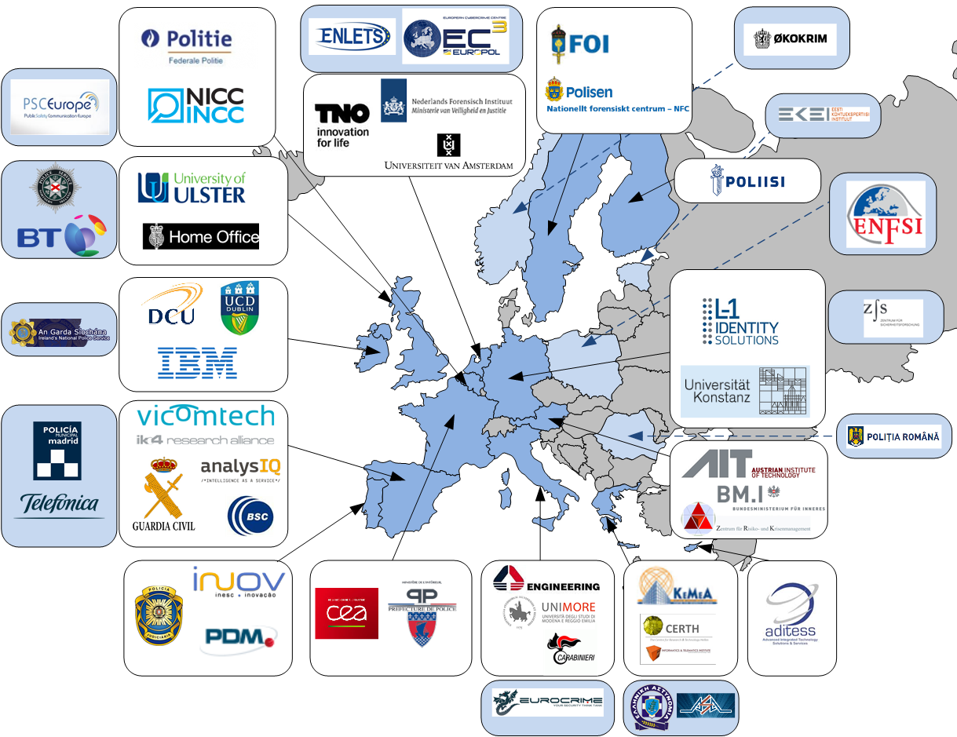

Conceptual view of the implementation strategy
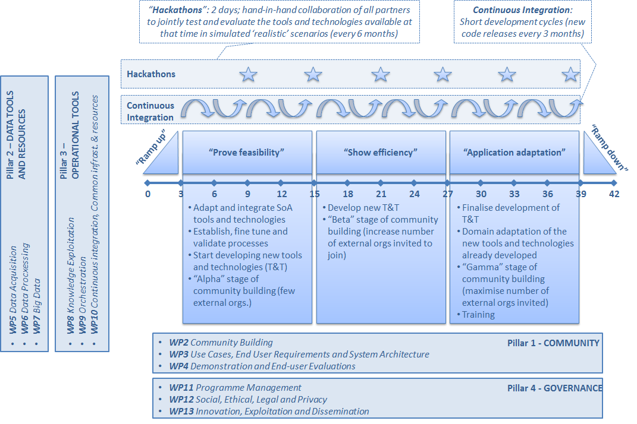

ASGARD components
